**Steps to remote a project to GitHub :**

**git init** // to initialized the existing Git repository

**git config --global user.name "Moez BEJAOUI"** // use the name to remote to GitHub

**git config --global user.email "bejaouimoez216@gmail.com"** // use mail to remote to GitHub

then we go to GitHub and create new project as the Screenshot show

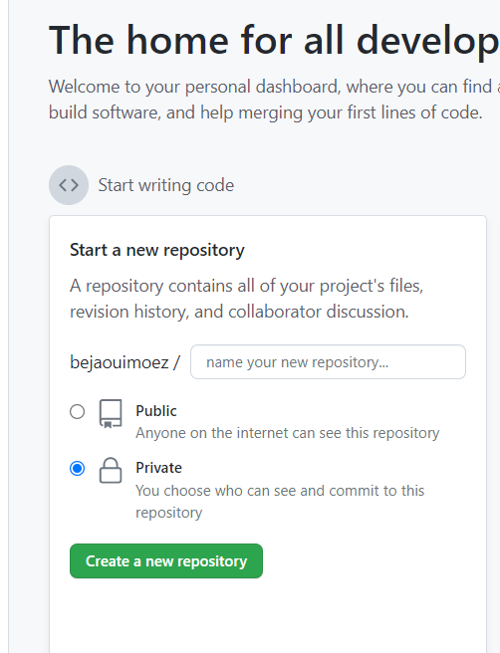

After that we must have a relationship between our local repository and GitHub so we use this command: ( the link in this command is our GitHub Project that I created previously )

**git remote add origin** [**https://github.com/bejaouimoez/newprojet**](https://github.com/bejaouimoez/newprojet)

**git push origin master** // we remote ( push) our work in GitHub

* The work now is on GitHub